Experiment-6

AIM

Tm simulation for palindrome w= ababa c

PROCEDURE

1. Start the automata
2. Enter the states
3. Connect the respective nodes (states) and self loop.
4. Enter the inputs values in the named nodes .
5. Compile the execution with suitable inputs
6. Stop the executions.

Design input:

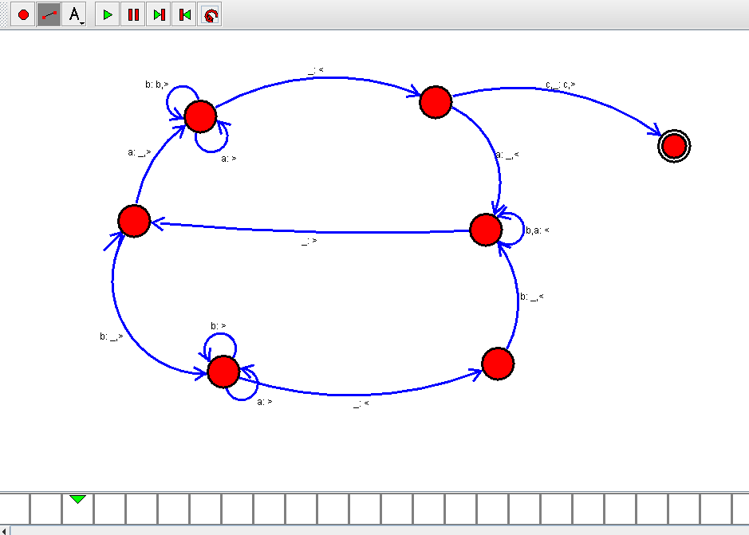

OUTPUT:

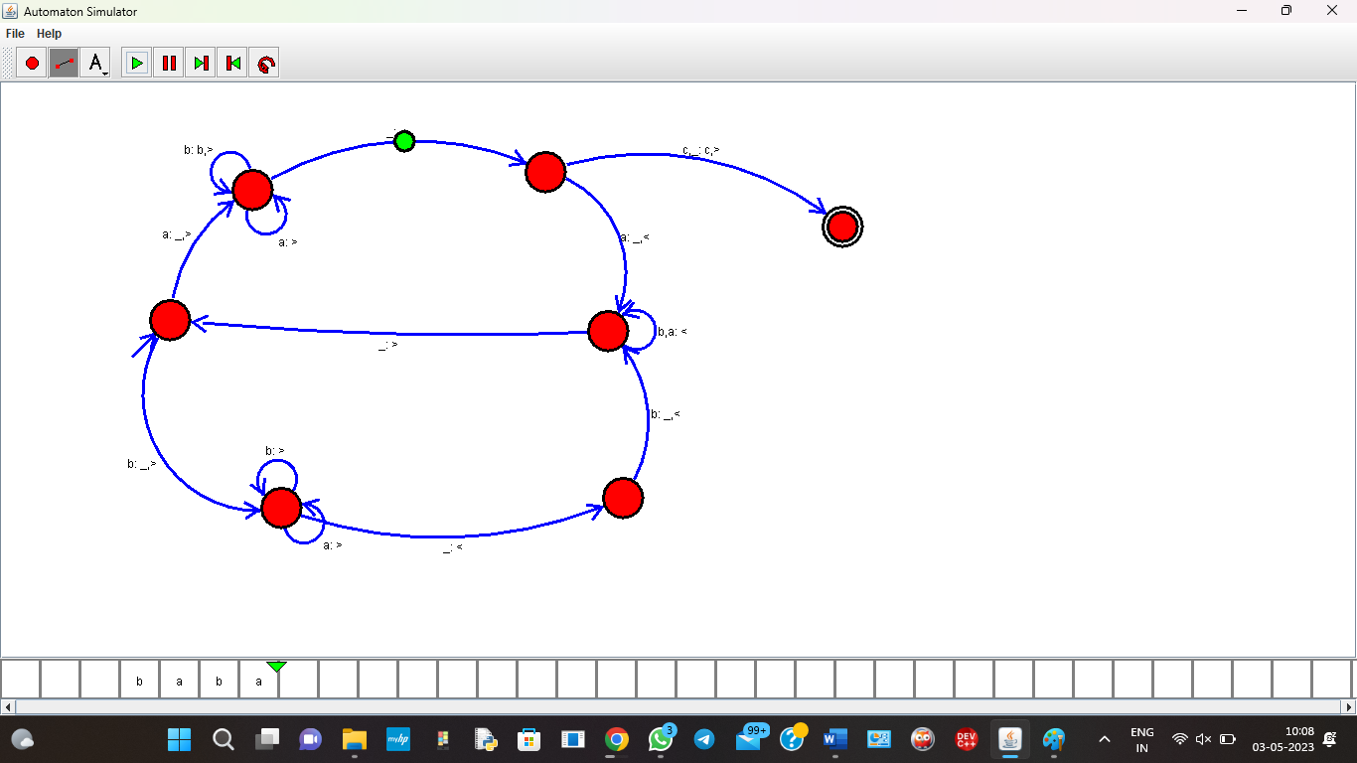

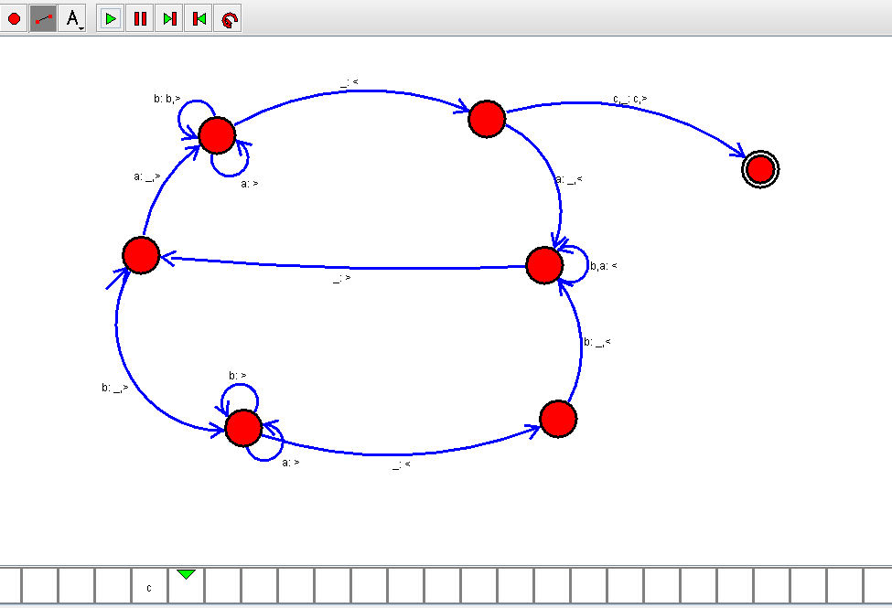

RESULT :

Thus the Design of Tm simulation for palindrome has been executed successfully.